[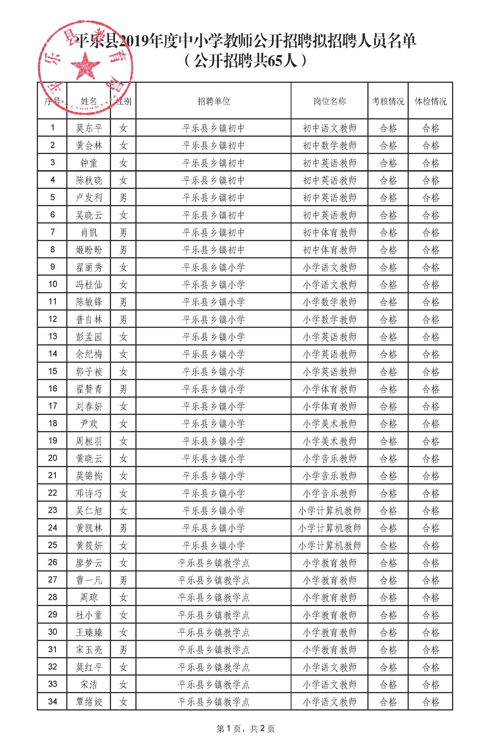](http://www.glsjyj.gov.cn/gggs/201908/W020190809433092381853.jpg)

公示（公开招聘）_页面_3

[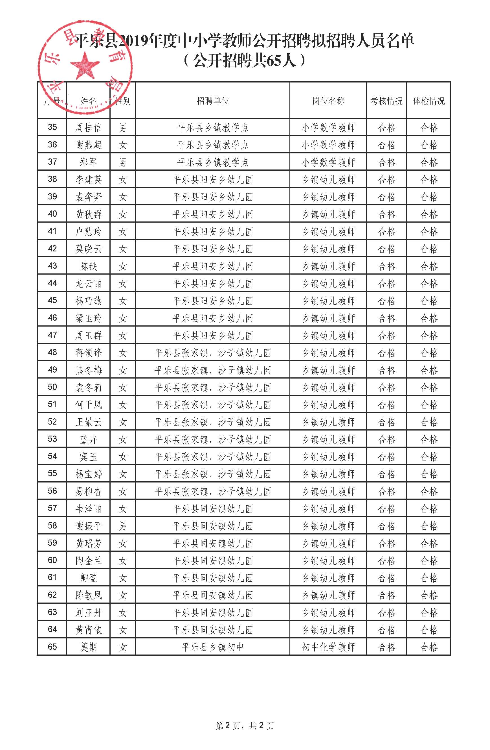](http://www.glsjyj.gov.cn/gggs/201908/W020190809433092709860.jpg)